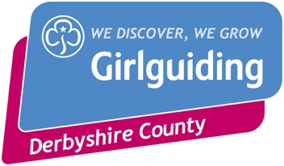

Fund pots that your units/districts or areas may be able to access.

Girlguiding website links:
- https://www.girlguiding.org.uk/making-guiding-happen/running-your-unit/finance-insurance-and-property/grants-and-funding/

- https://www.girlguiding.org.uk/get-involved/fundraise-for-us/fundraising-toolkit/applying-to-trusts-and-foundations/

- https://www.girlguiding.org.uk/making-guiding-happen/how-were-being-our-best/updates-for-our-members/how-to-apply-for-a-grant/

- https://www.girlguiding.org.uk/making-guiding-happen/running-your-unit/finance-insurance-and-property/grants-and-funding/trefoil-guild-new-unit-grant/

- https://www.girlguiding.org.uk/making-guiding-happen/running-your-unit/finance-insurance-and-property/grants-and-funding/fund-for-members-with-disabilities/

Other funding pots that you may be able to access:
- https://www.morrisonsfoundation.com/
- https://tescocommunitygrants.org.uk/
- http://www.highpeakcvs.org.uk/funding
- https://www.communityactionderby.org.uk/funding/funding-and-tender-alerts
- https://foundationderbyshire.org/apply-for-a-grant/available-grants/
- https://www.activederbyshire.org.uk/news/2021/09/up-to-10000-match-funding-crowdfunding-programme-for-local-groups

Some employers offer match funding for charities
- Barclays
- Some other high street banks
- Toyota
- Rolls Royce
- Ask the parents in your units if their employer does, here is a good template letter to ask for Match funding
  - https://www.pta.co.uk/pta/media/264-Match-funding-letter.docx

